Scenario 1
Scenario 1: Smart Campus Complaint Management System
Scenario 1: Emergency Rescue Priority System
Objective
Develop a C program to register emergency requests, prioritize critical cases, assign rescue teams, update request status, search records, and generate a summary.
Features Implemented
Register emergency requests with ID, location, people affected, emergency level, and required resources.
Assign priority: 1 – Critical, 2 – High, 3 – Normal.
Display requests in priority order using Bubble Sort.
Assign a rescue team and update the status to In Progress.
Update status to Pending, In Progress, or Resolved.
Search requests by ID using Linear Search.
Generate a summary of total, critical, pending, in-progress, and resolved requests.
C Concepts Used
Structures, arrays, strings, functions, if-else, loops, switch-case, Bubble Sort, Linear Search, strcmp(), and strcpy().
Limitation
Records are stored only while the program runs. File handling and automatic priority calculation can be added later.
PROGRAM:
#include <stdio.h>
#include <stdlib.h>
#include <string.h>
#include <ctype.h>

#define MAX_COMPLAINTS 100
#define FILE_NAME "complaints.dat"

#define LOW_PRIORITY 1
#define MEDIUM_PRIORITY 2
#define HIGH_PRIORITY 3

#define STATUS_PENDING 1
#define STATUS_IN_PROGRESS 2
#define STATUS_RESOLVED 3

typedef struct {
int id;
char category[30];
char description[200];
char location[50];
int severity;
int priority;
int status;
} Complaint;

Complaint complaints[MAX_COMPLAINTS];
int complaintCount = 0;

int saveComplaintsToFile(const char *fileName);
int loadComplaintsFromFile(const char *fileName);

void clearInputBuffer(void) {
int ch;
while ((ch = getchar()) != '\n' && ch != EOF) {
}
}

void trimNewline(char *text) {
size_t length = strlen(text);
while (length > 0 && (text[length - 1] == '\n' || text[length - 1] == '\r')) {
text[length - 1] = '\0';
length--;
}
}

int isBlankString(const char *text) {
while (*text != '\0') {
if (!isspace((unsigned char)*text)) {
return 0;
}
text++;
}
return 1;
}

void readString(const char *prompt, char *buffer, int size) {
char *newlinePos;

printf("%s", prompt);
if (fgets(buffer, size, stdin) == NULL) {
buffer[0] = '\0';
return;
}

newlinePos = strchr(buffer, '\n');
if (newlinePos == NULL && !feof(stdin)) {
clearInputBuffer();
}

trimNewline(buffer);

while (isBlankString(buffer)) {
printf("Invalid input. %s", prompt);
if (fgets(buffer, size, stdin) == NULL) {
buffer[0] = '\0';
return;
}

newlinePos = strchr(buffer, '\n');
if (newlinePos == NULL && !feof(stdin)) {
clearInputBuffer();
}

trimNewline(buffer);
}
}

int readIntRange(int minValue, int maxValue, const char *prompt) {
char buffer[32];
int value;

while (1) {
printf("%s", prompt);
if (fgets(buffer, sizeof(buffer), stdin) == NULL) {
clearInputBuffer();
continue;
}

trimNewline(buffer);

if (sscanf(buffer, "%d", &value) == 1 && value >= minValue && value <= maxValue) {
return value;
}

printf("Invalid input. Please enter a number between %d and %d.\n", minValue, maxValue);
}
}

const char *priorityToString(int priority) {
if (priority == HIGH_PRIORITY) {
return "High";
}
if (priority == MEDIUM_PRIORITY) {
return "Medium";
}
return "Low";
}

const char *statusToString(int status) {
if (status == STATUS_PENDING) {
return "Pending";
}
if (status == STATUS_IN_PROGRESS) {
return "In Progress";
}
return "Resolved";
}

int severityToPriority(int severity) {
if (severity >= 4) {
return HIGH_PRIORITY;
}
if (severity == 3) {
return MEDIUM_PRIORITY;
}
return LOW_PRIORITY;
}

int findComplaintIndexById(int id) {
for (int i = 0; i < complaintCount; i++) {
if (complaints[i].id == id) {
return i;
}
}
return -1;
}

int getNextComplaintId(void) {
int nextId = 1001;

for (int i = 0; i < complaintCount; i++) {
if (complaints[i].id >= nextId) {
nextId = complaints[i].id + 1;
}
}

return nextId;
}

void swapComplaints(Complaint *first, Complaint *second) {
Complaint temp = *first;
*first = *second;
*second = temp;
}

void printComplaintHeader(void) {
printf("\n%-8s %-18s %-20s %-15s %-10s %-15s\n",
"ID",
"Category",
"Location",
"Severity",
"Priority",
"Status");
printf("---------------------------------------------------------------------\n");
}

void displayComplaint(Complaint c) {
printf("%-8d %-18s %-20s %-15d %-10s %-15s\n",
c.id,
c.category,
c.location,
c.severity,
priorityToString(c.priority),
statusToString(c.status));
}

void displaySingleComplaintDetails(Complaint c) {
printf("\nComplaint Details\n");
printf("-----------------\n");
printf("Complaint ID : %d\n", c.id);
printf("Category : %s\n", c.category);
printf("Location : %s\n", c.location);
printf("Severity : %d/5\n", c.severity);
printf("Priority : %s\n", priorityToString(c.priority));
printf("Status : %s\n", statusToString(c.status));
printf("Description : %s\n", c.description);
}

void registerComplaint(void) {
Complaint newComplaint;

if (complaintCount >= MAX_COMPLAINTS) {
printf("Complaint limit reached. Please resolve earlier complaints first.\n");
return;
}

newComplaint.id = getNextComplaintId();
readString("Enter category: ", newComplaint.category, sizeof(newComplaint.category));
readString("Enter complaint description: ", newComplaint.description, sizeof(newComplaint.description));
readString("Enter location: ", newComplaint.location, sizeof(newComplaint.location));
newComplaint.severity = readIntRange(1, 5, "Enter severity (1-Low to 5-Critical): ");
newComplaint.priority = severityToPriority(newComplaint.severity);
newComplaint.status = STATUS_PENDING;

complaints[complaintCount++] = newComplaint;

printf("\nComplaint registered successfully.\n");
displaySingleComplaintDetails(newComplaint);

if (saveComplaintsToFile(FILE_NAME) == 0) {
printf("Complaint saved to file successfully.\n");
} else {
printf("Warning: File could not be saved.\n");
}
}

void viewAllComplaints(void) {
if (complaintCount == 0) {
printf("No complaints available.\n");
return;
}

printComplaintHeader();
for (int i = 0; i < complaintCount; i++) {
displayComplaint(complaints[i]);
}
printf("\n");
}

void searchComplaintById(void) {
int searchId;
int index;

searchId = readIntRange(1001, 999999, "Enter complaint ID to search: ");
index = findComplaintIndexById(searchId);

if (index == -1) {
printf("Complaint with ID %d was not found.\n", searchId);
return;
}

displaySingleComplaintDetails(complaints[index]);
}

void sortComplaintsByPriority(void) {
int option;

if (complaintCount < 2) {
printf("Not enough complaints to sort.\n");
return;
}

printf("\nSort Options\n");
printf("1. Priority: High to Low\n");
printf("2. Priority: Low to High\n");
printf("3. Severity: High to Low\n");
printf("4. Complaint ID: Low to High\n");
printf("5. Category (A to Z)\n");
option = readIntRange(1, 5, "Select sort option: ");

for (int i = 0; i < complaintCount - 1; i++) {
for (int j = i + 1; j < complaintCount; j++) {
int shouldSwap = 0;

if (option == 1) {
shouldSwap = complaints[i].priority < complaints[j].priority;
} else if (option == 2) {
shouldSwap = complaints[i].priority > complaints[j].priority;
} else if (option == 3) {
shouldSwap = complaints[i].severity < complaints[j].severity;
} else if (option == 4) {
shouldSwap = complaints[i].id > complaints[j].id;
} else if (option == 5) {
shouldSwap = strcmp(complaints[i].category, complaints[j].category) > 0;
}

if (shouldSwap) {
swapComplaints(&complaints[i], &complaints[j]);
}
}
}

printf("Complaints sorted successfully.\n");
viewAllComplaints();
}

void updateComplaintStatus(void) {
int id;
int index;
int newStatus;

id = readIntRange(1001, 999999, "Enter complaint ID to update: ");
index = findComplaintIndexById(id);

if (index == -1) {
printf("Complaint with ID %d was not found.\n", id);
return;
}

printf("Current status: %s\n", statusToString(complaints[index].status));
printf("1. Pending\n2. In Progress\n3. Resolved\n");
newStatus = readIntRange(1, 3, "Choose new status: ");
complaints[index].status = newStatus;

printf("Status updated successfully.\n");
displaySingleComplaintDetails(complaints[index]);

if (saveComplaintsToFile(FILE_NAME) == 0) {
printf("Updated complaint saved to file.\n");
}
}

void viewPendingComplaints(void) {
int found = 0;

for (int i = 0; i < complaintCount; i++) {
if (complaints[i].status == STATUS_PENDING) {
if (!found) {
printComplaintHeader();
found = 1;
}
displayComplaint(complaints[i]);
}
}

if (!found) {
printf("No pending complaints available.\n");
}
}

void printCategoryStatistics(void) {
char categories[MAX_COMPLAINTS][30];
int counts[MAX_COMPLAINTS];
int uniqueCount = 0;

for (int i = 0; i < complaintCount; i++) {
int found = 0;

for (int j = 0; j < uniqueCount; j++) {
if (strcmp(complaints[i].category, categories[j]) == 0) {
counts[j]++;
found = 1;
break;
}
}

if (!found) {
strcpy(categories[uniqueCount], complaints[i].category);
counts[uniqueCount] = 1;
uniqueCount++;
}
}

if (uniqueCount == 0) {
printf("No complaint category data available.\n");
return;
}

printf("\nDepartment / Category-wise Complaint Statistics\n");
printf("--------------------------------------------\n");
for (int i = 0; i < uniqueCount; i++) {
printf("%-20s : %d\n", categories[i], counts[i]);
}
}

void generateComplaintSummary(void) {
int pending = 0;
int inProgress = 0;
int resolved = 0;
int highPriority = 0;
int mediumPriority = 0;
int lowPriority = 0;

for (int i = 0; i < complaintCount; i++) {
if (complaints[i].status == STATUS_PENDING) {
pending++;
} else if (complaints[i].status == STATUS_IN_PROGRESS) {
inProgress++;
} else if (complaints[i].status == STATUS_RESOLVED) {
resolved++;
}

if (complaints[i].priority == HIGH_PRIORITY) {
highPriority++;
} else if (complaints[i].priority == MEDIUM_PRIORITY) {
mediumPriority++;
} else {
lowPriority++;
}
}

printf("\nComplaint Summary\n");
printf("----------------\n");
printf("Total Complaints : %d\n", complaintCount);
printf("Pending Complaints : %d\n", pending);
printf("In Progress Complaints: %d\n", inProgress);
printf("Resolved Complaints : %d\n", resolved);
printf("High Priority : %d\n", highPriority);
printf("Medium Priority : %d\n", mediumPriority);
printf("Low Priority : %d\n", lowPriority);

printCategoryStatistics();
}

void filterComplaints(void) {
int option;
char keyword[50];
int found = 0;
int desiredStatus = -1;

printf("\nFilter Complaints\n");
printf("1. By Category\n");
printf("2. By Location\n");
printf("3. By Status\n");
printf("4. Back to main menu\n");
option = readIntRange(1, 4, "Select filter option: ");

if (option == 4) {
return;
}

if (option == 3) {
printf("1. Pending\n2. In Progress\n3. Resolved\n");
desiredStatus = readIntRange(1, 3, "Select status: ");
} else {
readString("Enter filter value: ", keyword, sizeof(keyword));
}

for (int i = 0; i < complaintCount; i++) {
int matches = 0;

if (option == 1) {
matches = strcmp(complaints[i].category, keyword) == 0;
} else if (option == 2) {
matches = strcmp(complaints[i].location, keyword) == 0;
} else if (option == 3) {
matches = complaints[i].status == desiredStatus;
}

if (matches) {
if (!found) {
printComplaintHeader();
found = 1;
}
displayComplaint(complaints[i]);
}
}

if (!found) {
printf("No complaints matched the filter.\n");
}
}

int saveComplaintsToFile(const char *fileName) {
FILE *file = fopen(fileName, "wb");

if (file == NULL) {
return 1;
}

fwrite(&complaintCount, sizeof(int), 1, file);
fwrite(complaints, sizeof(Complaint), complaintCount, file);
fclose(file);
return 0;
}

int loadComplaintsFromFile(const char *fileName) {
FILE *file = fopen(fileName, "rb");

if (file == NULL) {
complaintCount = 0;
return 0;
}

fread(&complaintCount, sizeof(int), 1, file);

if (complaintCount < 0 || complaintCount > MAX_COMPLAINTS) {
complaintCount = 0;
fclose(file);
return 1;
}

fread(complaints, sizeof(Complaint), complaintCount, file);
fclose(file);
return 0;
}

void printMenu(void) {
printf("\n==========================================\n");
printf("Smart Campus Complaint Management System\n");
printf("==========================================\n");
printf("1. Register a Complaint\n");
printf("2. View All Complaints\n");
printf("3. Search Complaint\n");
printf("4. Sort Complaints by Priority\n");
printf("5. Update Complaint Status\n");
printf("6. View Pending Complaints\n");
printf("7. Filter Complaints\n");
printf("8. Generate Complaint Summary\n");
printf("9. Save and Exit\n");
printf("==========================================\n");
}

int main(void) {
int choice;

loadComplaintsFromFile(FILE_NAME);
printf("Welcome to the Smart Campus Complaint System.\n");

while (1) {
printMenu();
choice = readIntRange(1, 9, "Enter your choice: ");

switch (choice) {
case 1:
registerComplaint();
break;
case 2:
viewAllComplaints();
break;
case 3:
searchComplaintById();
break;
case 4:
sortComplaintsByPriority();
break;
case 5:
updateComplaintStatus();
break;
case 6:
viewPendingComplaints();
break;
case 7:
filterComplaints();
break;
case 8:
generateComplaintSummary();
break;
case 9:
if (saveComplaintsToFile(FILE_NAME) == 0) {
printf("Complaints saved successfully. Exiting program.\n");
} else {
printf("Failed to save complaints. Exiting program anyway.\n");
}
return 0;
default:
printf("Invalid menu choice. Please try again.\n");
break;
}
}

return 0;
}
OUTPUT
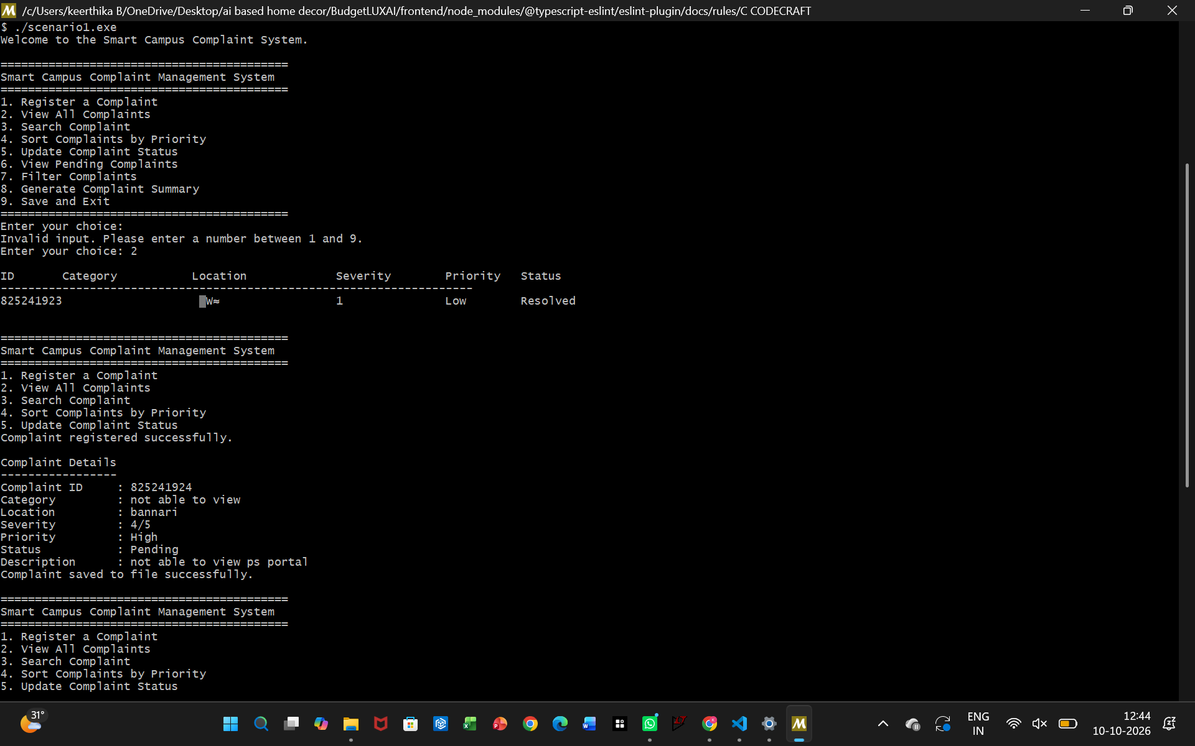

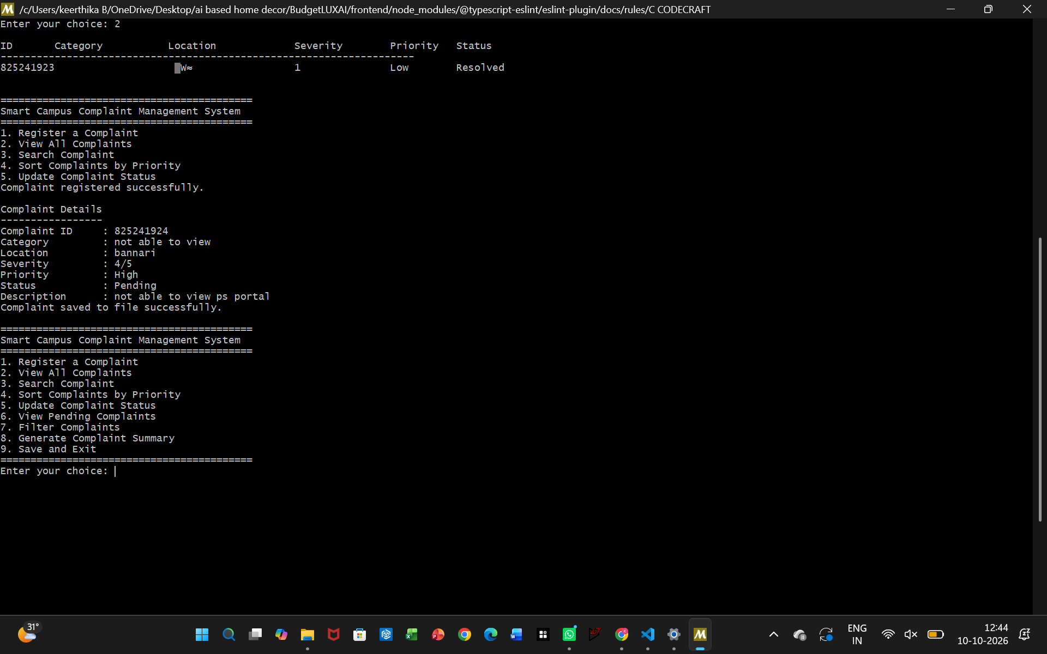
SCENARIO 2
#include <stdio.h>
#include <stdlib.h>
#include <string.h>
#include <ctype.h>

#define MAX_COMPLAINTS 200
#define FILE_NAME "complaints.dat"

#define LOW_PRIORITY 1
#define MEDIUM_PRIORITY 2
#define HIGH_PRIORITY 3

#define STATUS_PENDING 1
#define STATUS_IN_PROGRESS 2
#define STATUS_RESOLVED 3

typedef struct {
char complaintId[12];
char category[30];
char description[200];
char location[50];
int severity;
int priority;
int status;
} Complaint;

Complaint complaints[MAX_COMPLAINTS];
int complaintCount = 0;
static int sortMode = 0;

int saveComplaintsToFile(const char *fileName);
int loadComplaintsFromFile(const char *fileName);

void clearInputBuffer(void) {
int ch;
while ((ch = getchar()) != '\n' && ch != EOF) {
}
}

void trimNewline(char *text) {
size_t len = strlen(text);
if (len > 0 && text[len - 1] == '\n') {
text[len - 1] = '\0';
}
}

int isBlankString(const char *text) {
while (*text != '\0') {
if (!isspace((unsigned char)*text)) {
return 0;
}
text++;
}
return 1;
}

void readNonEmptyString(const char *prompt, char *buffer, size_t size) {
do {
printf("%s", prompt);
if (fgets(buffer, (int)size, stdin) == NULL) {
buffer[0] = '\0';
return;
}

trimNewline(buffer);

if (isBlankString(buffer)) {
printf("Invalid input. Please enter a meaningful value.\n");
}
} while (isBlankString(buffer));
}

int readIntRange(int minValue, int maxValue, const char *prompt) {
char buffer[32];
int value;

while (1) {
printf("%s", prompt);
if (fgets(buffer, sizeof(buffer), stdin) == NULL) {
clearInputBuffer();
continue;
}

trimNewline(buffer);

if (sscanf(buffer, "%d", &value) == 1 && value >= minValue && value <= maxValue) {
return value;
}

printf("Invalid input. Please enter a number between %d and %d.\n", minValue, maxValue);
}
}

const char *priorityToString(int priority) {
if (priority == HIGH_PRIORITY) {
return "High";
}
if (priority == MEDIUM_PRIORITY) {
return "Medium";
}
return "Low";
}

const char *statusToString(int status) {
if (status == STATUS_PENDING) {
return "Pending";
}
if (status == STATUS_IN_PROGRESS) {
return "In Progress";
}
return "Resolved";
}

int severityToPriority(int severity) {
if (severity >= 4) {
return HIGH_PRIORITY;
}
if (severity == 3) {
return MEDIUM_PRIORITY;
}
return LOW_PRIORITY;
}

int extractComplaintNumber(const char *complaintId) {
int number = 0;
if (sscanf(complaintId, "C%d", &number) == 1) {
return number;
}
return 0;
}

int findComplaintIndexById(const char *complaintId) {
for (int i = 0; i < complaintCount; i++) {
if (strcmp(complaints[i].complaintId, complaintId) == 0) {
return i;
}
}
return -1;
}

void generateComplaintId(char *buffer, size_t bufferSize) {
int maxNumber = 100;

for (int i = 0; i < complaintCount; i++) {
int currentNumber = extractComplaintNumber(complaints[i].complaintId);
if (currentNumber > maxNumber) {
maxNumber = currentNumber;
}
}

snprintf(buffer, bufferSize, "C%d", maxNumber + 1);
}

void toLowerCaseString(char *text) {
for (size_t i = 0; text[i] != '\0'; i++) {
text[i] = (char)tolower((unsigned char)text[i]);
}
}

int containsIgnoreCase(const char *source, const char *search) {
char sourceCopy[200];
char searchCopy[200];

if (strlen(source) >= sizeof(sourceCopy) || strlen(search) >= sizeof(searchCopy)) {
return 0;
}

strcpy(sourceCopy, source);
strcpy(searchCopy, search);
toLowerCaseString(sourceCopy);
toLowerCaseString(searchCopy);

return strstr(sourceCopy, searchCopy) != NULL;
}

void printComplaintHeader(void) {
printf("\n%-12s %-18s %-20s %-10s %-10s %-15s\n",
"ID",
"Category",
"Location",
"Severity",
"Priority",
"Status");
printf("--------------------------------------------------------------------------\n");
}

void displayComplaintRow(const Complaint *complaint) {
printf("%-12s %-18s %-20s %-10d %-10s %-15s\n",
complaint->complaintId,
complaint->category,
complaint->location,
complaint->severity,
priorityToString(complaint->priority),
statusToString(complaint->status));
}

void displayComplaintDetails(const Complaint *complaint) {
printf("\nComplaint Details\n");
printf("-----------------\n");
printf("Complaint ID : %s\n", complaint->complaintId);
printf("Category : %s\n", complaint->category);
printf("Location : %s\n", complaint->location);
printf("Severity : %d/5\n", complaint->severity);
printf("Priority : %s\n", priorityToString(complaint->priority));
printf("Status : %s\n", statusToString(complaint->status));
printf("Description : %s\n", complaint->description);
}

void registerComplaint(void) {
Complaint newComplaint;

if (complaintCount >= MAX_COMPLAINTS) {
printf("Complaint limit reached. Please resolve earlier complaints first.\n");
return;
}

generateComplaintId(newComplaint.complaintId, sizeof(newComplaint.complaintId));
readNonEmptyString("Enter category: ", newComplaint.category, sizeof(newComplaint.category));
readNonEmptyString("Enter complaint description: ", newComplaint.description, sizeof(newComplaint.description));
readNonEmptyString("Enter location: ", newComplaint.location, sizeof(newComplaint.location));
newComplaint.severity = readIntRange(1, 5, "Enter severity (1-5): ");
newComplaint.priority = severityToPriority(newComplaint.severity);
newComplaint.status = STATUS_PENDING;

complaints[complaintCount++] = newComplaint;

printf("\nComplaint registered successfully.\n");
displayComplaintDetails(&newComplaint);

if (saveComplaintsToFile(FILE_NAME) == 0) {
printf("Complaint saved to file successfully.\n");
} else {
printf("Warning: Complaint could not be saved to file.\n");
}
}

void viewAllComplaints(void) {
if (complaintCount == 0) {
printf("No complaints available.\n");
return;
}

printComplaintHeader();
for (int i = 0; i < complaintCount; i++) {
displayComplaintRow(&complaints[i]);
}
printf("\n");
}

void searchComplaint(void) {
int option;
char searchValue[50];
int found = 0;

printf("\nSearch Complaint\n");
printf("1. By Complaint ID\n");
printf("2. By Category\n");
printf("3. By Location\n");
option = readIntRange(1, 3, "Select search type: ");

readNonEmptyString("Enter search value: ", searchValue, sizeof(searchValue));

for (int i = 0; i < complaintCount; i++) {
int matches = 0;

if (option == 1) {
matches = strcmp(complaints[i].complaintId, searchValue) == 0;
} else if (option == 2) {
matches = containsIgnoreCase(complaints[i].category, searchValue);
} else if (option == 3) {
matches = containsIgnoreCase(complaints[i].location, searchValue);
}

if (matches) {
if (!found) {
printComplaintHeader();
found = 1;
}
displayComplaintRow(&complaints[i]);
}
}

if (!found) {
printf("No complaint matched the search.\n");
}
}

int compareComplaintsForSort(const void *left, const void *right) {
const Complaint *a = (const Complaint *)left;
const Complaint *b = (const Complaint *)right;

switch (sortMode) {
case 1:
if (a->priority != b->priority) {
return (a->priority < b->priority) ? 1 : -1;
}
if (a->severity != b->severity) {
return (a->severity < b->severity) ? 1 : -1;
}
return strcmp(a->complaintId, b->complaintId);
case 2:
if (a->priority != b->priority) {
return (a->priority > b->priority) ? 1 : -1;
}
if (a->severity != b->severity) {
return (a->severity > b->severity) ? 1 : -1;
}
return strcmp(a->complaintId, b->complaintId);
case 3:
if (a->severity != b->severity) {
return (a->severity < b->severity) ? 1 : -1;
}
if (a->priority != b->priority) {
return (a->priority < b->priority) ? 1 : -1;
}
return strcmp(a->complaintId, b->complaintId);
case 4: {
int aNumber = extractComplaintNumber(a->complaintId);
int bNumber = extractComplaintNumber(b->complaintId);
if (aNumber != bNumber) {
return (aNumber > bNumber) ? 1 : -1;
}
return strcmp(a->complaintId, b->complaintId);
}
case 5:
if (strcmp(a->category, b->category) != 0) {
return strcmp(a->category, b->category);
}
return strcmp(a->complaintId, b->complaintId);
case 6:
if (strcmp(a->location, b->location) != 0) {
return strcmp(a->location, b->location);
}
return strcmp(a->complaintId, b->complaintId);
default:
return strcmp(a->complaintId, b->complaintId);
}
}

void sortComplaints(void) {
int option;

if (complaintCount < 2) {
printf("Not enough complaints to sort.\n");
return;
}

printf("\nSort Complaints\n");
printf("1. Priority: High to Low\n");
printf("2. Priority: Low to High\n");
printf("3. Severity: High to Low\n");
printf("4. Complaint ID: Low to High\n");
printf("5. Category (A to Z)\n");
printf("6. Location (A to Z)\n");
option = readIntRange(1, 6, "Select sort option: ");

sortMode = option;
qsort(complaints, (size_t)complaintCount, sizeof(Complaint), compareComplaintsForSort);

printf("Complaints sorted successfully.\n");
viewAllComplaints();
}

void updateComplaintStatus(void) {
char complaintId[12];
int index;
int newStatus;

readNonEmptyString("Enter complaint ID to update: ", complaintId, sizeof(complaintId));
index = findComplaintIndexById(complaintId);

if (index == -1) {
printf("Complaint with ID %s was not found.\n", complaintId);
return;
}

printf("Current status: %s\n", statusToString(complaints[index].status));
printf("1. Pending\n2. In Progress\n3. Resolved\n");
newStatus = readIntRange(1, 3, "Choose new status: ");
complaints[index].status = newStatus;

printf("Status updated successfully.\n");
displayComplaintDetails(&complaints[index]);

if (saveComplaintsToFile(FILE_NAME) == 0) {
printf("Updated complaint saved to file.\n");
} else {
printf("Warning: Failed to save updated complaint.\n");
}
}

void viewPendingComplaints(void) {
int found = 0;

for (int i = 0; i < complaintCount; i++) {
if (complaints[i].status == STATUS_PENDING) {
if (!found) {
printComplaintHeader();
found = 1;
}
displayComplaintRow(&complaints[i]);
}
}

if (!found) {
printf("No pending complaints available.\n");
}
}

void printCategoryStatistics(void) {
char categories[MAX_COMPLAINTS][30];
int counts[MAX_COMPLAINTS];
int uniqueCount = 0;

for (int i = 0; i < complaintCount; i++) {
int found = 0;

for (int j = 0; j < uniqueCount; j++) {
if (strcmp(complaints[i].category, categories[j]) == 0) {
counts[j]++;
found = 1;
break;
}
}

if (!found) {
strcpy(categories[uniqueCount], complaints[i].category);
counts[uniqueCount] = 1;
uniqueCount++;
}
}

if (uniqueCount == 0) {
printf("No complaint category data available.\n");
return;
}

printf("\nDepartment / Category-wise Complaint Statistics\n");
printf("----------------------------------------------\n");
for (int i = 0; i < uniqueCount; i++) {
printf("%-20s : %d\n", categories[i], counts[i]);
}
}

void generateComplaintSummary(void) {
int pending = 0;
int inProgress = 0;
int resolved = 0;
int highPriority = 0;
int mediumPriority = 0;
int lowPriority = 0;

for (int i = 0; i < complaintCount; i++) {
if (complaints[i].status == STATUS_PENDING) {
pending++;
} else if (complaints[i].status == STATUS_IN_PROGRESS) {
inProgress++;
} else if (complaints[i].status == STATUS_RESOLVED) {
resolved++;
}

if (complaints[i].priority == HIGH_PRIORITY) {
highPriority++;
} else if (complaints[i].priority == MEDIUM_PRIORITY) {
mediumPriority++;
} else {
lowPriority++;
}
}

printf("\nComplaint Summary\n");
printf("----------------\n");
printf("Total Complaints : %d\n", complaintCount);
printf("Pending Complaints : %d\n", pending);
printf("In Progress Complaints : %d\n", inProgress);
printf("Resolved Complaints : %d\n", resolved);
printf("High Priority Complaints : %d\n", highPriority);
printf("Medium Priority Complaints: %d\n", mediumPriority);
printf("Low Priority Complaints : %d\n", lowPriority);

printCategoryStatistics();
}

void filterComplaints(void) {
int option;
char keyword[50];
int desiredStatus = -1;
int found = 0;

printf("\nFilter Complaints\n");
printf("1. By Category\n");
printf("2. By Location\n");
printf("3. By Status\n");
printf("4. Back to main menu\n");
option = readIntRange(1, 4, "Select filter option: ");

if (option == 4) {
return;
}

if (option == 3) {
printf("1. Pending\n2. In Progress\n3. Resolved\n");
desiredStatus = readIntRange(1, 3, "Select status: ");
} else {
readNonEmptyString("Enter filter value: ", keyword, sizeof(keyword));
}

for (int i = 0; i < complaintCount; i++) {
int matches = 0;

if (option == 1) {
matches = containsIgnoreCase(complaints[i].category, keyword);
} else if (option == 2) {
matches = containsIgnoreCase(complaints[i].location, keyword);
} else if (option == 3) {
matches = complaints[i].status == desiredStatus;
}

if (matches) {
if (!found) {
printComplaintHeader();
found = 1;
}
displayComplaintRow(&complaints[i]);
}
}

if (!found) {
printf("No complaints matched the filter.\n");
}
}

void generateResolutionPerformanceReport(void) {
int resolvedComplaints = 0;
int unresolvedComplaints = 0;
double resolvedPercent = 0.0;
double unresolvedPercent = 0.0;

for (int i = 0; i < complaintCount; i++) {
if (complaints[i].status == STATUS_RESOLVED) {
resolvedComplaints++;
} else {
unresolvedComplaints++;
}
}

if (complaintCount > 0) {
resolvedPercent = (double)resolvedComplaints / complaintCount * 100.0;
unresolvedPercent = (double)unresolvedComplaints / complaintCount * 100.0;
}

printf("\nResolution Performance Report\n");
printf("----------------------------\n");
printf("Total Complaints : %d\n", complaintCount);
printf("Resolved Complaints : %d\n", resolvedComplaints);
printf("Unresolved Complaints : %d\n", unresolvedComplaints);
printf("Resolved Percentage : %.2f%%\n", resolvedPercent);
printf("Unresolved Percentage : %.2f%%\n", unresolvedPercent);
}

int saveComplaintsToFile(const char *fileName) {
FILE *file = fopen(fileName, "wb");

if (file == NULL) {
return 1;
}

if (fwrite(&complaintCount, sizeof(int), 1, file) != 1) {
fclose(file);
return 1;
}

if (complaintCount > 0 && fwrite(complaints, sizeof(Complaint), (size_t)complaintCount, file) != (size_t)complaintCount) {
fclose(file);
return 1;
}

fclose(file);
return 0;
}

int loadComplaintsFromFile(const char *fileName) {
FILE *file = fopen(fileName, "rb");

if (file == NULL) {
complaintCount = 0;
return 0;
}

if (fread(&complaintCount, sizeof(int), 1, file) != 1) {
fclose(file);
complaintCount = 0;
return 1;
}

if (complaintCount < 0 || complaintCount > MAX_COMPLAINTS) {
fclose(file);
complaintCount = 0;
return 1;
}

if (complaintCount > 0 && fread(complaints, sizeof(Complaint), (size_t)complaintCount, file) != (size_t)complaintCount) {
fclose(file);
complaintCount = 0;
return 1;
}

fclose(file);
return 0;
}

void printMenu(void) {
printf("\n=============================================\n");
printf("Smart Campus Complaint Management System\n");
printf("=============================================\n");
printf("1. Register a Complaint\n");
printf("2. View All Complaints\n");
printf("3. Search Complaint\n");
printf("4. Sort Complaints\n");
printf("5. Update Complaint Status\n");
printf("6. View Pending Complaints\n");
printf("7. Filter Complaints\n");
printf("8. Generate Complaint Summary\n");
printf("9. Department-wise Statistics\n");
printf("10. Resolution Performance Report\n");
printf("11. Save and Exit\n");
printf("=============================================\n");
}

int main(void) {
int choice;

if (loadComplaintsFromFile(FILE_NAME) != 0) {
printf("Warning: Existing complaint file is invalid or corrupted. Starting with an empty list.\n");
}

printf("Welcome to the Smart Campus Complaint System.\n");

while (1) {
printMenu();
choice = readIntRange(1, 11, "Enter your choice: ");

switch (choice) {
case 1:
registerComplaint();
break;
case 2:
viewAllComplaints();
break;
case 3:
searchComplaint();
break;
case 4:
sortComplaints();
break;
case 5:
updateComplaintStatus();
break;
case 6:
viewPendingComplaints();
break;
case 7:
filterComplaints();
break;
case 8:
generateComplaintSummary();
break;
case 9:
printCategoryStatistics();
break;
case 10:
generateResolutionPerformanceReport();
break;
case 11:
if (saveComplaintsToFile(FILE_NAME) == 0) {
printf("Complaints saved successfully. Exiting program.\n");
} else {
printf("Failed to save complaints. Exiting program anyway.\n");
}
return 0;
default:
printf("Invalid menu choice. Please try again.\n");
break;
}
}

return 0;
}
OUTPUT:
